Lab 11A: Regression diagnostics.

Question 1. Assumptions of General Linear Models:
Using the following data set, we want to calculate the sum of squared errors for simple regression model. Note that the best fitting linear model for these data is: ${\hat{y}}_{i}=3.00+0.50\left(x_{i}\right)$.

ID | X-value | Y-value | $$Model A: {\hat{y}}_{i}$$ | $$({\hat{y}}_{i}-y_{i})$$ | $${\left({\hat{y}}_{i}-y_{i}\right)}^{2}$$
1 | 10 | 9.14
2 | 8 | 8.14
3 | 13 | 8.74
4 | 9 | 8.77
5 | 11 | 9.26
6 | 14 | 8.10
7 | 6 | 6.13
8 | 4 | 3.10
9 | 12 | 9.13
10 | 7 | 7.26
11 | 5 | 4.74
 |  |  |  | SSE(A) =
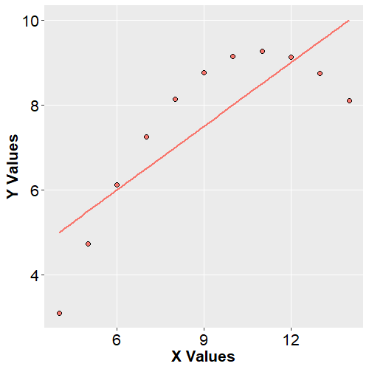
Use the equation to fill in the table above, then used the sum of squared errors from that table to fill in the ANOVA table below.
Source | SSE | df | MSE | F_obs | PRE
Model
Error(Residuals)
Total

So far, we have conducted a simple regression like what we have done in previous examples. However, we also need to check several assumptions of our general linear model. There are three assumptions that we need to confirm:
- The residuals of the model are independent.
- The residuals of the model are normally distributed.
- The residuals of the model have a constant variance.
As there is no clustering of the data (i.e., each datapoint comes from a separate person unrelated to other people in our sample), we can say that assumption #1 has been met. To check the other assumptions, however, we can analyze a number of different plots in R.
Below are plots showing important relationships that we can use to test our regression diagnostics. Top left, a plot showing the residuals (errors from Model A) as a function of the “fitted” values (the ${\hat{y}}_{i}$from Model A). Top right, a normal quantile-quantile plot snowing the standardized residuals plotted against their theoretical quantiles under a true normal distribution. Bottom-left, a scale-location plot showing the square root of the absolute value of the standardized residuals as a function of the fitted values. Bottom-right, a residuals-leverage plot showing standardized residuals as a function of the leverage they exert on the model.
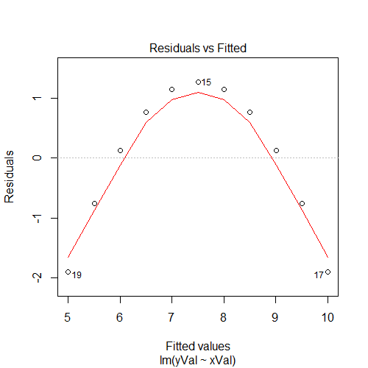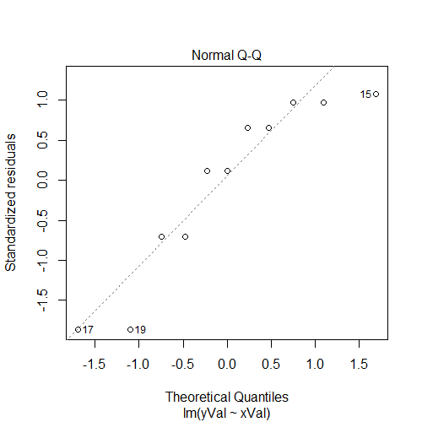
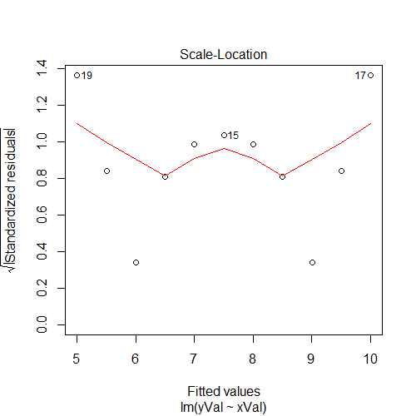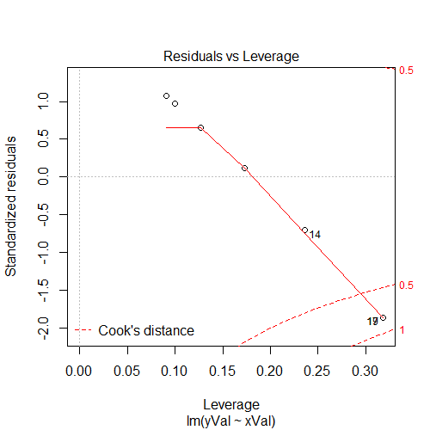
- What assumption is being checked with each figure? (Hint one of them isn’t necessarily testing an assumption, but it is still important to check!)

Question 2. Identifying Outliers:
Leverage and outlying data do not necessarily violate assumptions (although they often do!), but they are still very important to check. Outlying values (either dependent values or predictors values) can distort existing relationships in the data. As such, it is useful to check for both univariate and multivariate outliers to see the effect that individual data-points have on your model.
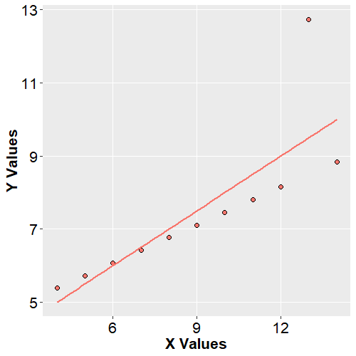
ID | X-value | Y-value | $$x_{i}-\overline{x}$$ | $$y_{i}-\overline{y}$$
1 | 10 | 7.46
2 | 8 | 6.77
3 | 13 | 12.74
4 | 9 | 7.11
5 | 11 | 7.81
6 | 14 | 8.84
7 | 6 | 6.08
8 | 4 | 5.39
9 | 12 | 8.15
10 | 7 | 6.42
11 | 5 | 5.73

In order to determine if an x-value is an outlier, we can compute its leverage by taking the following:
$$h_{i}=\frac{1}{n}+\frac{{\left(x_{i}-\overline{x}\right)}^{2}}{{\sum{(x_{i}}-\overline{x})}^{2} }$$
To determine if a y-value is unusual, it is helpful to look at the residuals in addition to the univariate distribution of y. The book discusses the “studentized deleted residual” in more detail, but by default R presents the “standardized residual”. These two different re-expressions of the residual are both useful, but it is important to remember that they are distinct.
The standardized residual is simply a given error relative to the standard deviation of all of the errors:
$$r_{i}=\frac{e_{i}}{s\left(e_{i}\right)}=\frac{(y_{i}-{\hat{y}}_{i})}{\sqrt{\frac{\sum{{\left(y_{i}-{\hat{y}}_{i}\right)}^{2}}}{(n-1)}}}$$
The studentized deleted residual for any given data point is calculated based on a regression line that was fit to all of the other data points except the one in question. That is, how much of an outlier would this data-point have been if we hadn’t included it to begin with? (Not that this calculation is also sometimes called an "externally studentized residual", "deleted residual", or "jackknifed residual".)
The studentized deleted residual sounds way more computationally difficult (because it sounds like we'd have to fit one new model for every point!), but fortunately there is a relatively easy way to compute it from just the original model without refitting. Once we calculate the standardized residual, we can obtain a studentized deleted residual ($t_{i}$) by taking:
$$t_{i}=r_{i}\sqrt{\frac{(n-k-2)}{(n-k-1-r_{i}^{2})}}$$
Where $r_{i}$ is the standardized residual, n is the number of observations and k is the number of parameters.
In the plot below, note how this outlying data point not only leads to a violation of our assumptions, but is exerting undue influence on our model as measured by Cook’s Distance, which can be computed from the basic components of the original regression:
$$Cook^{'}s D=\frac{e_{i}^{2}}{PA\left(MSE\right)}\left(\frac{h_{i}}{{\left(1-h_{i}\right)}^{2}}\right)$$
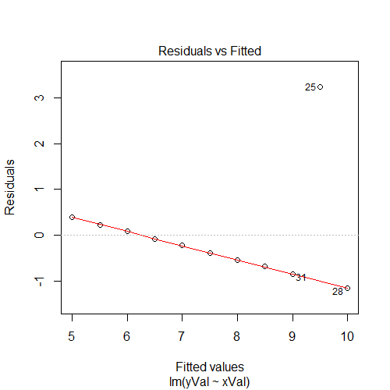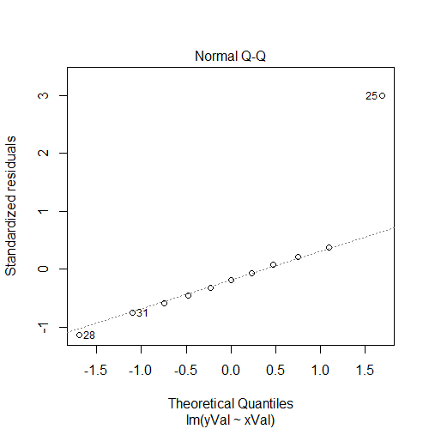
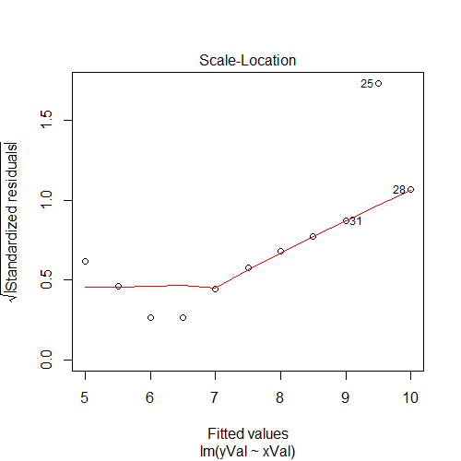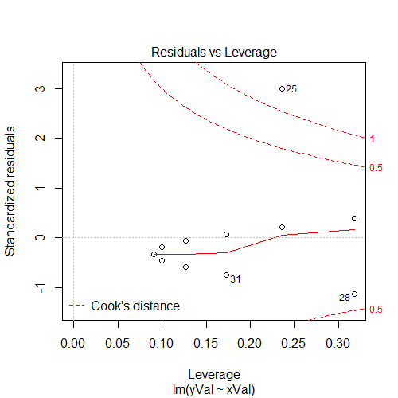

Always check your regression diagnostics!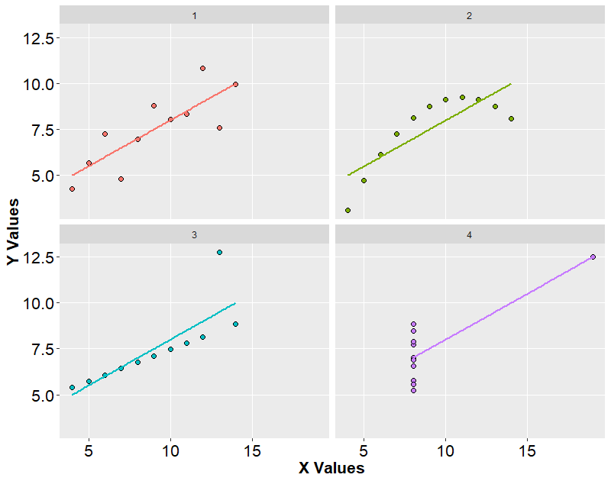
[Anscombe, F. (1961). Examination of residuals. Proc. 4th Berkeley Symp. 1, 1-36.]

